

Online Book Club Project

DOCUMENTATION



March 17, 2020

Mikhail goulding

Table of Contents

Program Design 2

Program Description 3

Operating System 3

System Requirements 4

The type and version of programs used 4

Installation and Setup 5

Website 9

Account Creation 10

Login 11

View Books 12

Rate Books 13

Submit Books 14

Change Personal Details 14

Change Password 15

Log File 16

Database 17

IntelliSense warnings in the Online Book Club Project 19

Bibliography 20

# Program Design

My project folder contains 4 folders:

* + **Online Book Club**
    - The website project folder.
  + **Book Club Web Service**
    - The web-service project folder.
  + **Resources backup**
    - Backup files. This folder can be ignored.
  + **Documentation**
    - The folder containing this document as pdf and docx.

The website uses an access database in order to store the book, user and rating information.  
The access database can be found in “…\Online Book Club\Online Book Club\**BookClub.accdb**”

The access database contains 3 tables:

* **Books**
  + Book details stored here.
* **Ratings**
  + User ratings for books stored here.
* **Users**
  + User details stored here.

*A backup of the access database can be found in the “****Resources backup****” folder. Please note that this is just a backup and* ***will not*** *update when information is changed/added through the website.*

A log file, which logs ratings, can be found here: “\Online Book Club\Online Book Club\**ratinglog.txt**”

Please note that all the files in the **website** section below, are **web-forms** that each have their own code-behind file (**filename.aspx.cs**)**.**Below is a list of the main files in each project, and a short description of each:

* **Web service** *(Book Club Web Service)*
  + BookClubWebService.asmx.cs
    - All web-methods used for interacting with the database are stored here.
  + Book.cs
    - This class stores the details of a book, in order to use it as a return object.
* **Website** *(Online Book Club)* 
  + Site.Master
    - The master page, used to load the navigation bar and footer, for all pages in the website.
  + Default.aspx
    - The home page, **please start here**.
  + Login.aspx
    - The user logs in from this page.
  + Create-Account.aspx
    - The user creates an account from this page.
  + About.aspx
    - Information about the website is shown here.
  + Contact.aspx
    - Contact information is shown here.
  + Terms.aspx
    - Terms and Conditions page.
  + Privacy.aspx
    - Privacy Policy page.
  + Reset-Username.aspx
    - Used for entering a username, when user wishes to reset his password.
  + Reset.aspx
    - The user resets his password from this page.
  + Books.aspx
    - Displays a list of all books in the database. User can select a book.
  + Selected-Book.aspx
    - User can view information about the selected book. User can rate the book and view the average rating.
  + Add-Book.aspx
    - User adds a new book to the database from this page.
  + Profile.aspx.
    - User can reset or view his personal details from this page.

# Program Description

This project is a rating website. It allows users to rate books from 1-5 stars, and post books to be rated.

The main features of the website are listed below:

* Create an account.
* Log-in / log-out.
* View list of books.
* View selected book’s details.
* Rate selected book and view book’s average rating.
* Write user rating details to log file.
* Submit a new book.
* Change personal details.
* Change password. (Separate from changing personal details.)
* Redirecting to login page if user attempts to view pages that require a successful logon.

# Operating System

It is recommended that you use Windows 7 or later.  
This program was only tested on Windows 7 and 10.

# System Requirements

Windows 7 or later with .Net Framework version 4.7.2 and Visual Studios 2019 installed.

Dual Core Processor (2.4GHz+ recommended)

8GB RAM (**required** to run web-service and website)

At least 200 MB of available hard disk space available.

The type and version of programs used

Visual Studios 2019 with .NET Framework version 4.7.2 is used and required.  
The program will **NOT** run without .NET Framework 4.7.2 installed.

Microsoft Access *(part of Office 365)* is required in order to read the access database.

# Installation and Setup

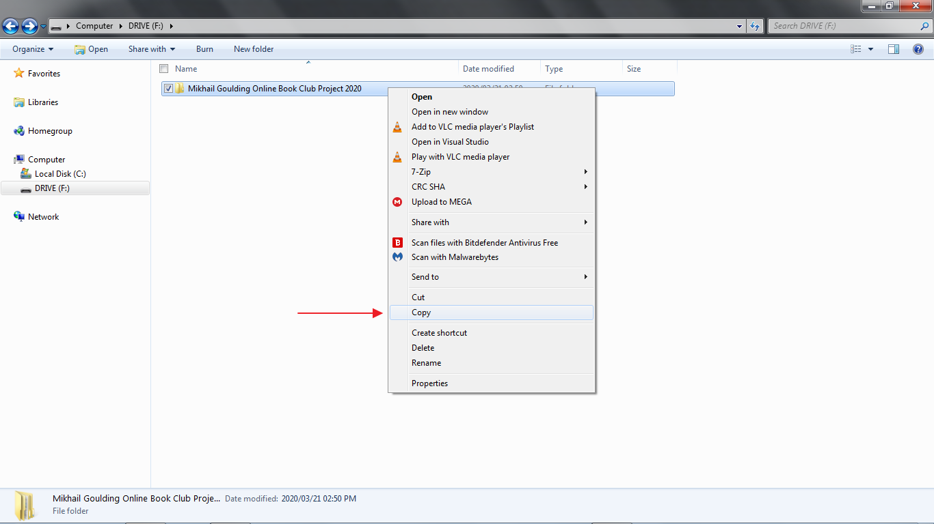Copy the project folder inside the CD/DVD drive. Do **not** attempt to run the project directly from the CD/DVD, it will not function properly.

Paste the copied project to your desktop.

The project should now be on your desktop.

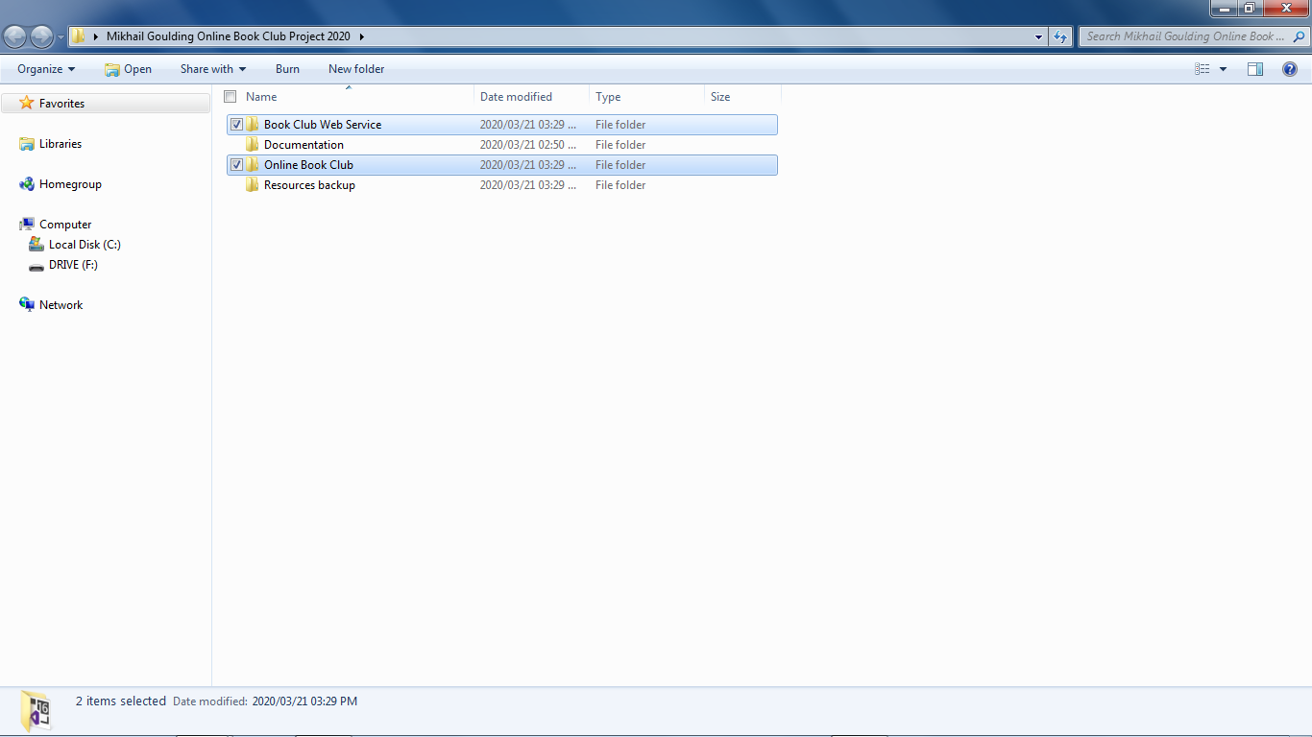Inside the folder, the **Book Club Web Service** and **Online Book Club** need to be run. This will be explained on the next page.

Inside the **Book Club Web Service** folder, open **Book Club Web Service.sln**

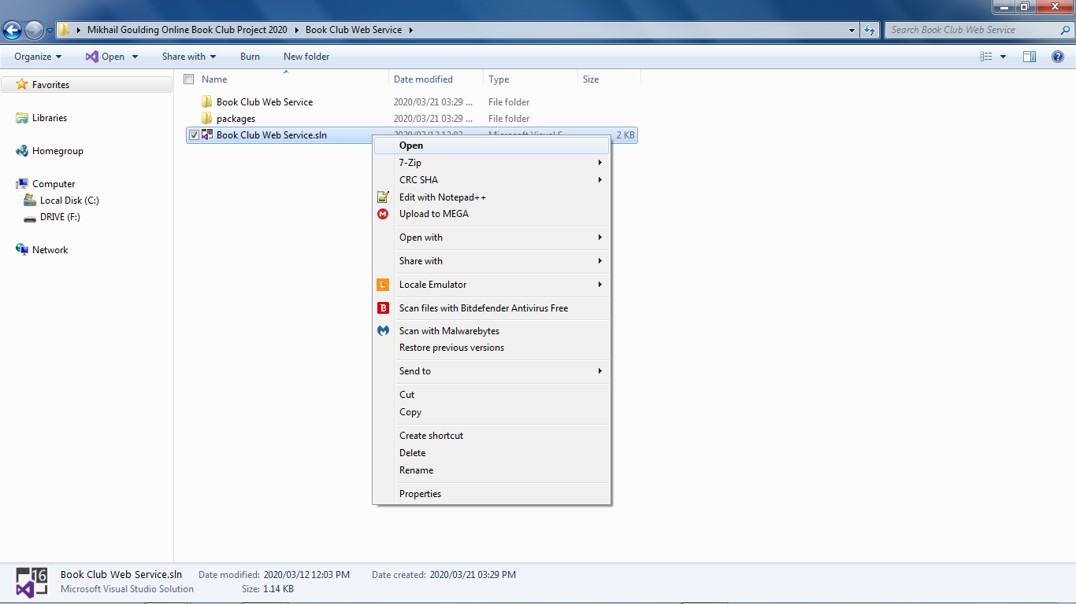

Open **BookClubWebService.asmx** in the solution explorer and press **F5**; or click the IIS Express button.

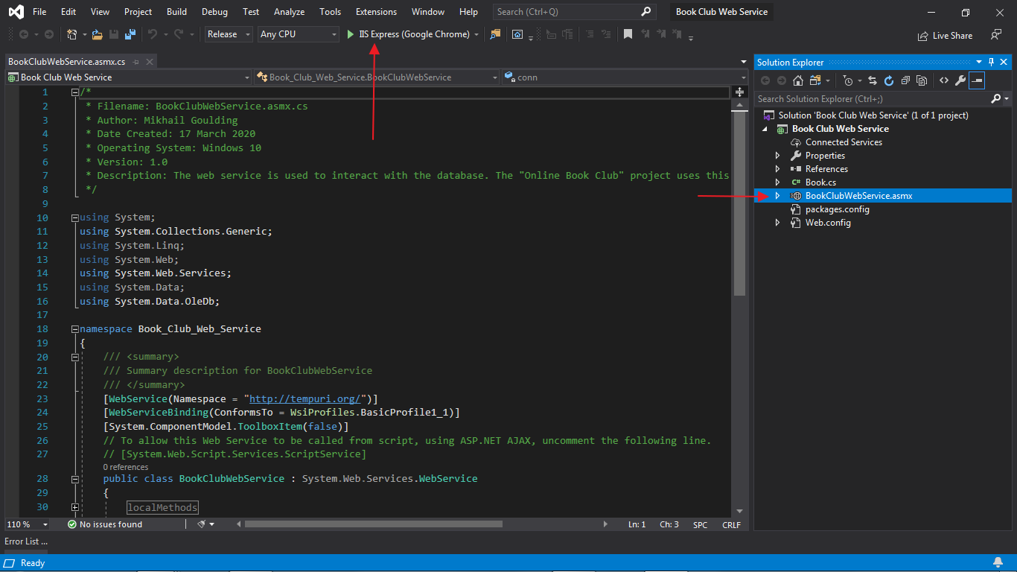

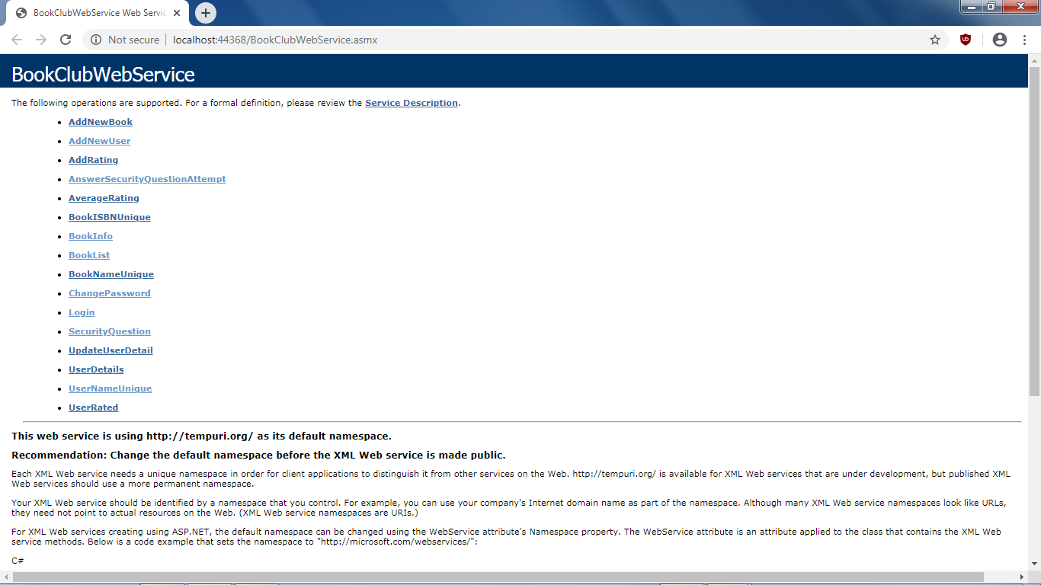The web service has now started; leave it open in the background. The website will not work if this is not running.

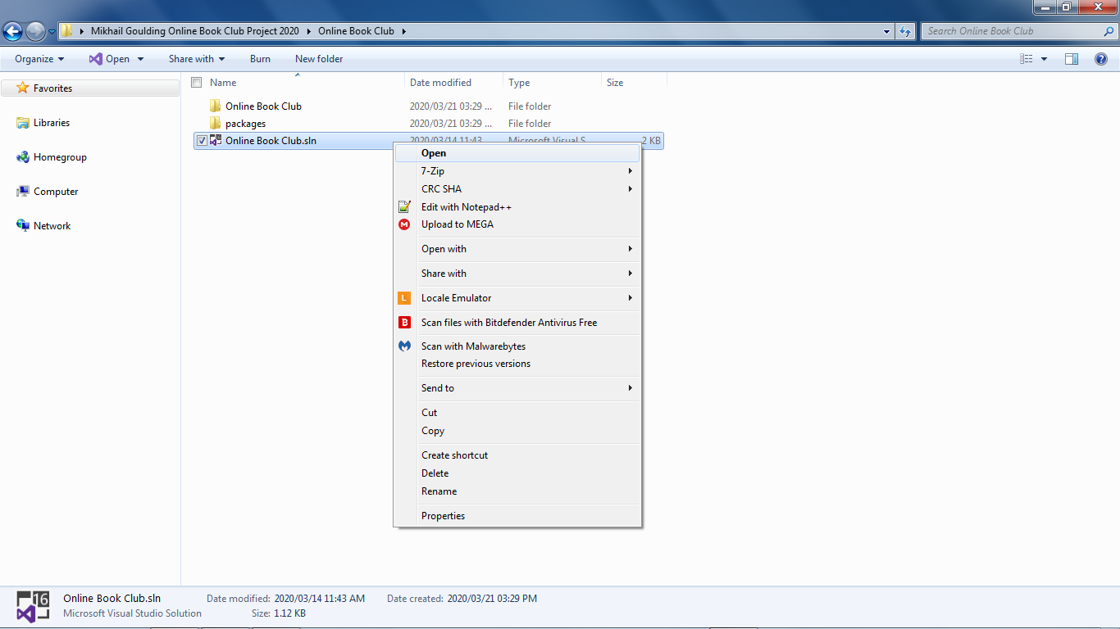Back inside the project folder, go to the **Online Book Club** folder and open **Online Book Club.sln**

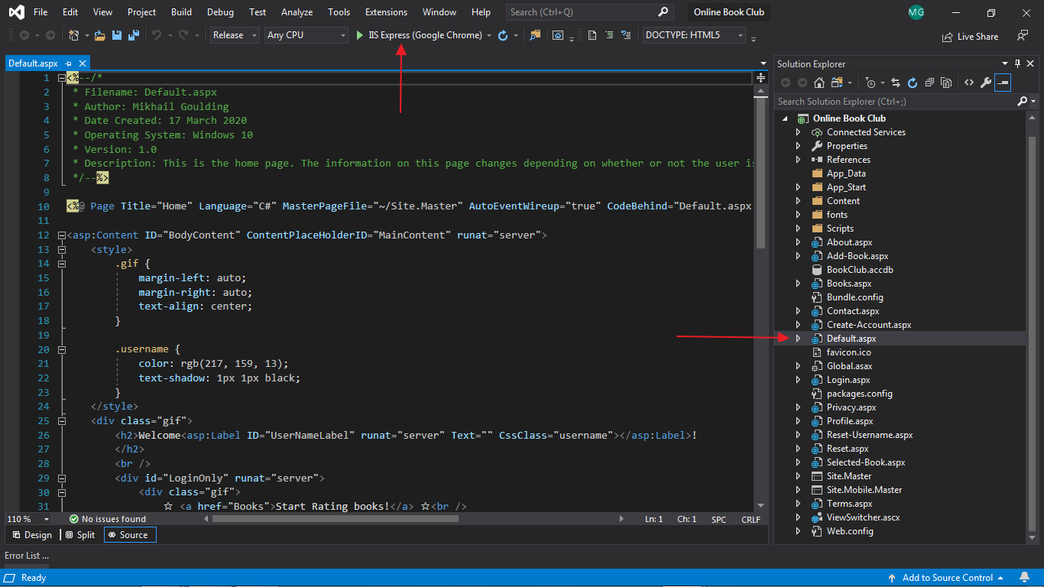Open **Default.aspx** *(the home page)* in the solution explorer and press F5; or click the IIS Express button.

# Website

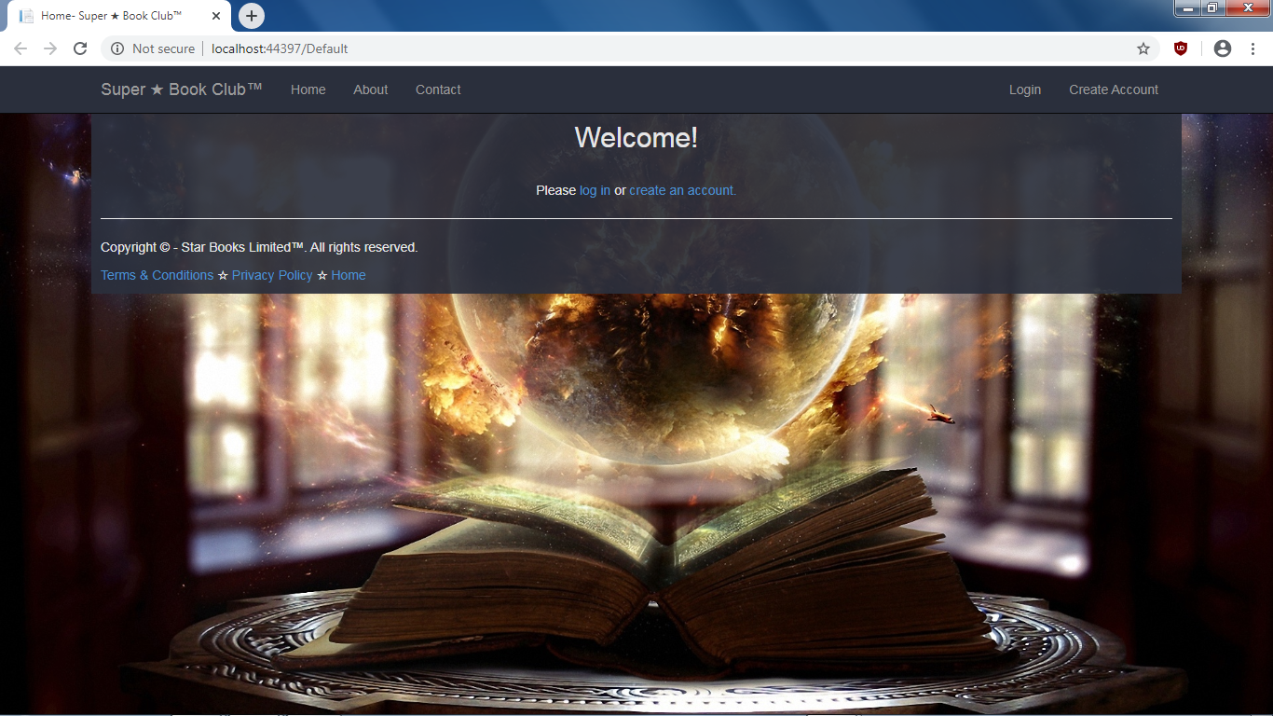The website has now started. Make sure the web service is running, and then **create an account**.

## Account Creation

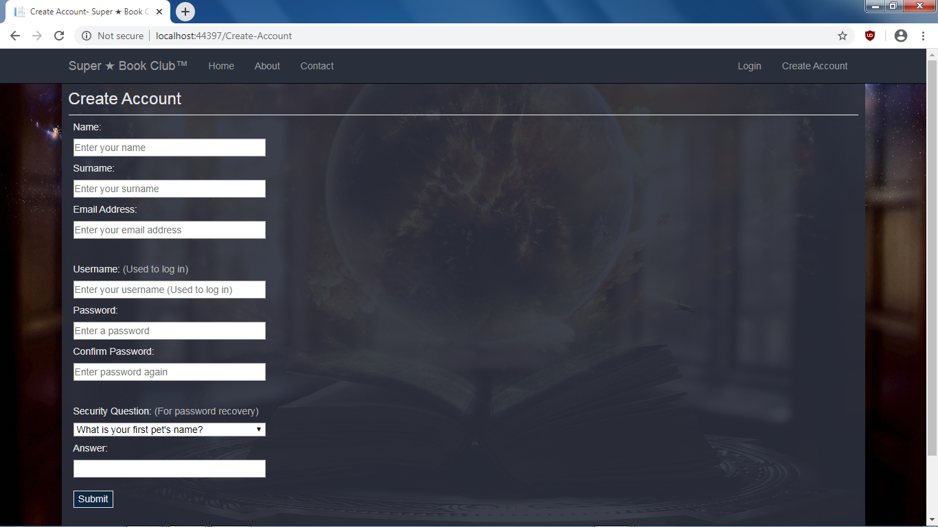This is the account creation page.

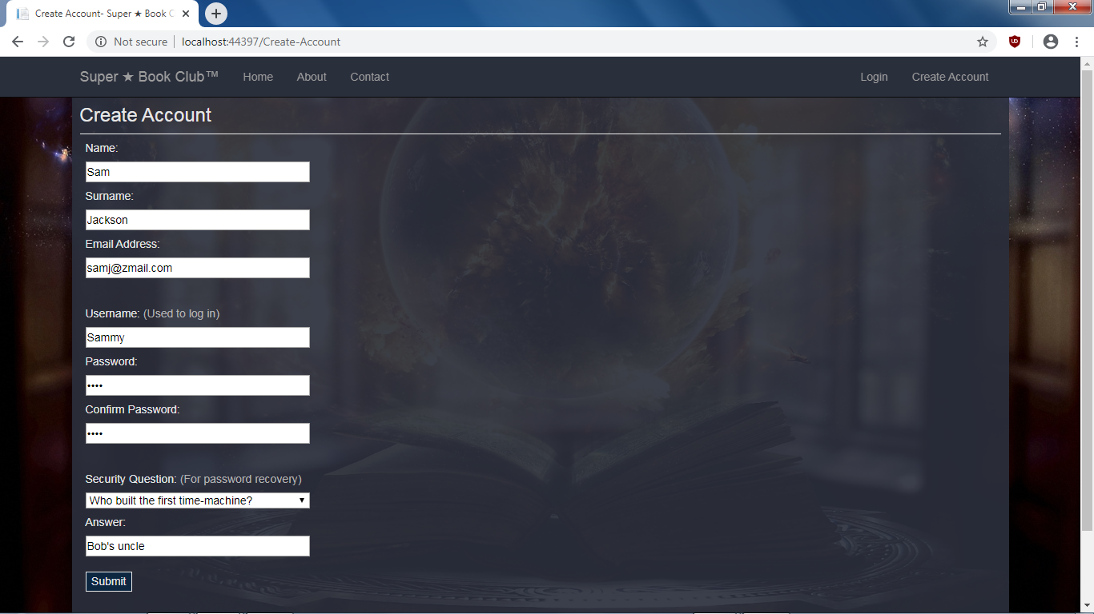Example account creation:

## Login

Once an account is created, you are redirected to the **login** page. *(You can reset your password here, or on the home page, once logged in.)*

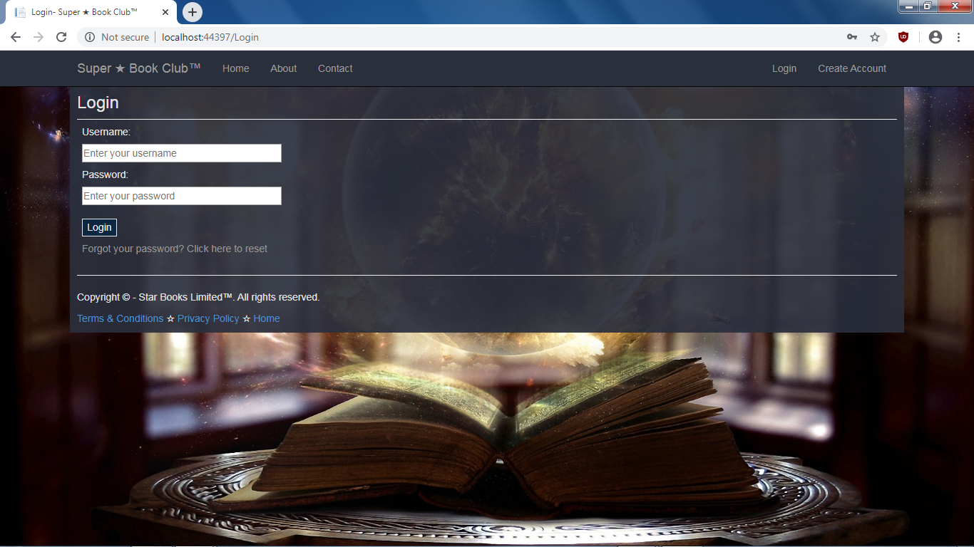

User login example:

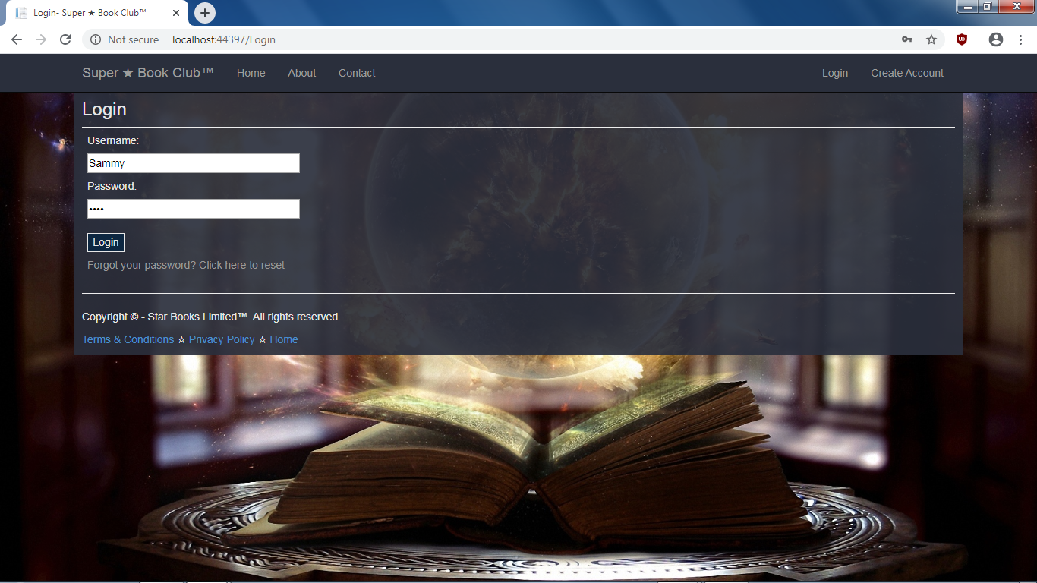

## View Books

Once logged in, you are redirected to the home page. *(Same home page as before, just looks a bit different when logged in.)*Click on the **Books** link in the navigation bar, or on the **Start Rating books!** link.

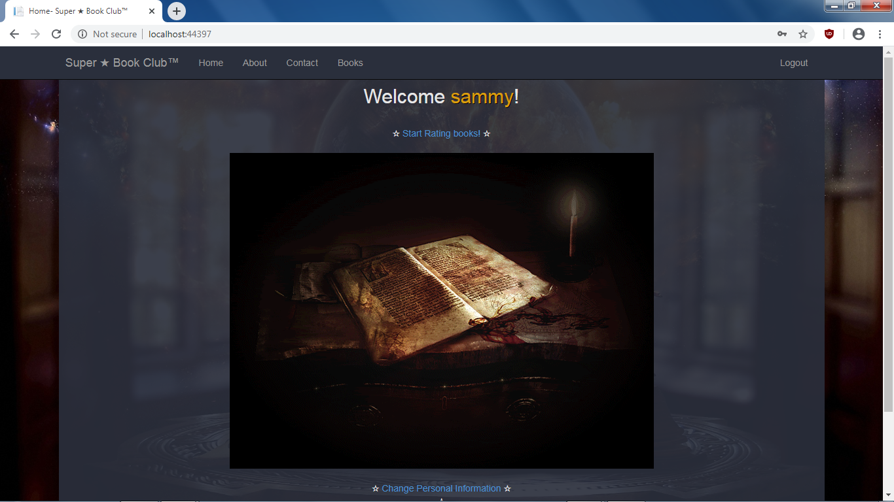

This is the books page. You can **select** a book or **submit** a new one.

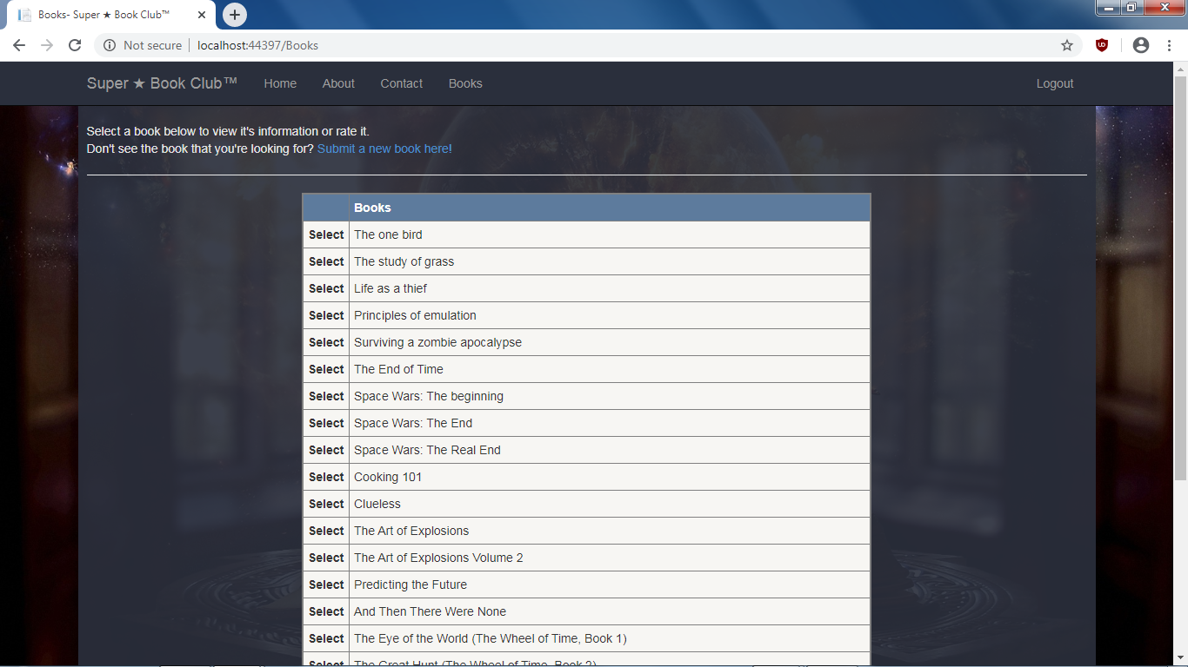

## Rate Books

Book selection:

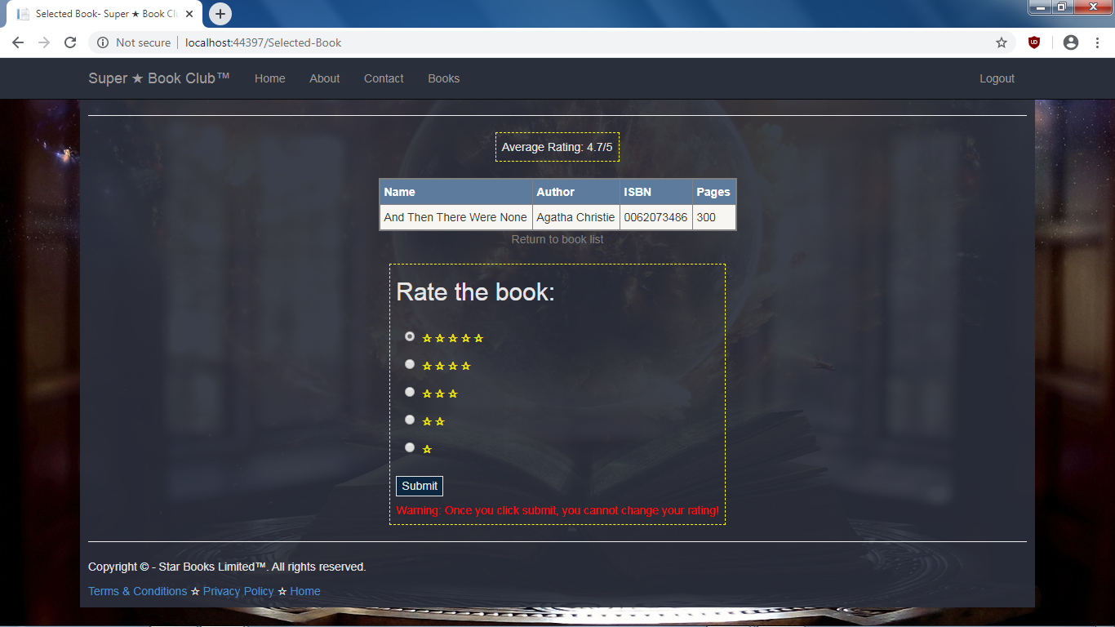

Book selection after being rated:

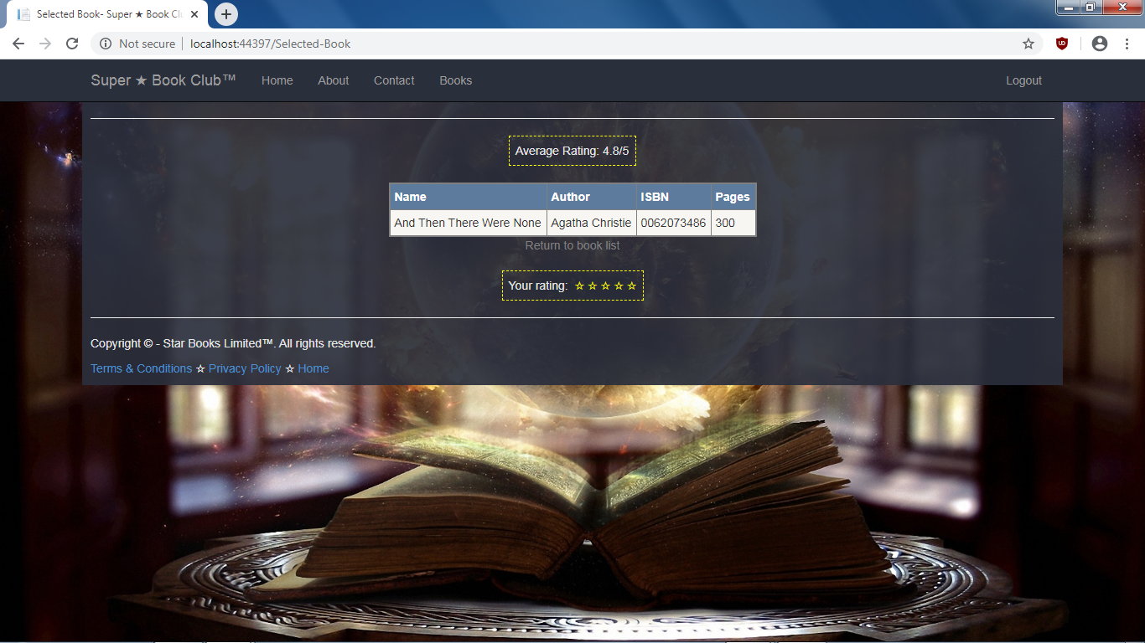

## Submit Books

Book submission page:

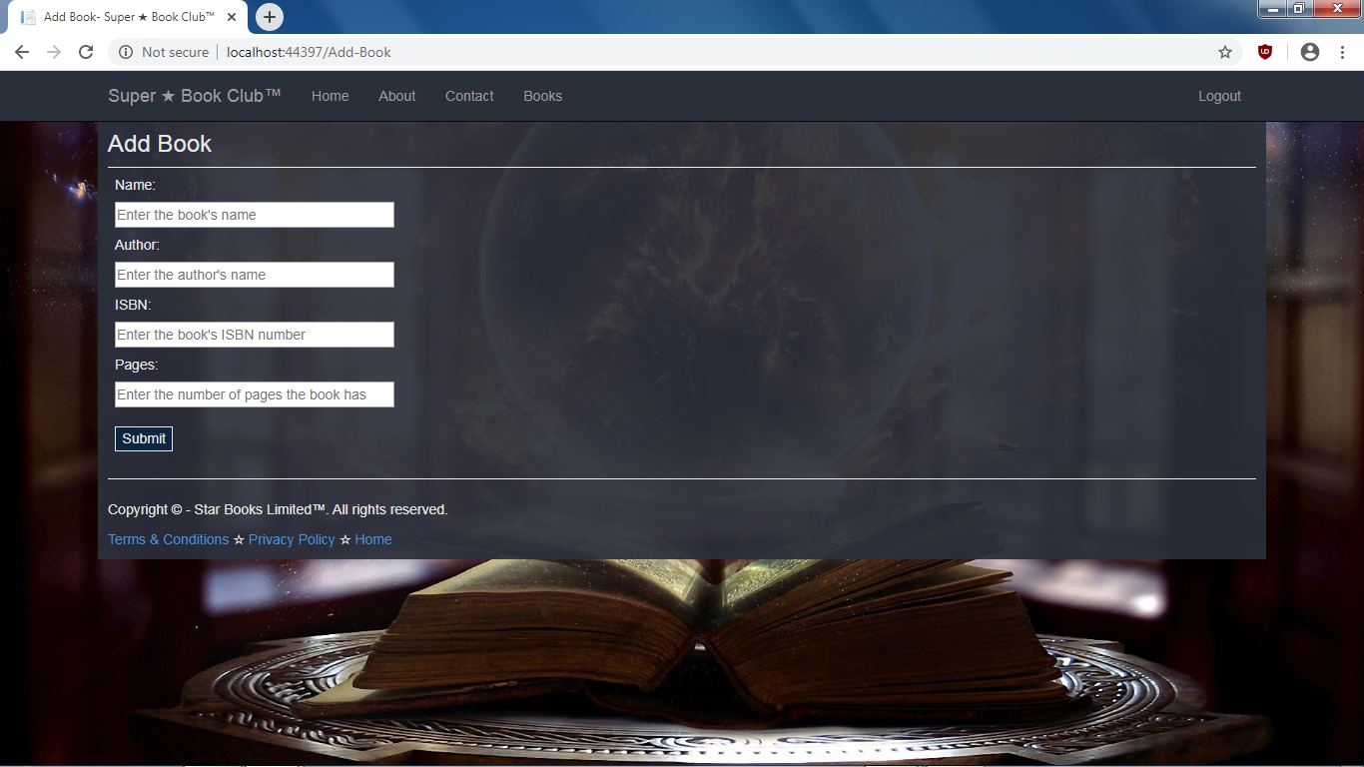

## Change Personal Details

Back on the home page, while logged in, you can change your personal information or password by clicking on the appropriate link.

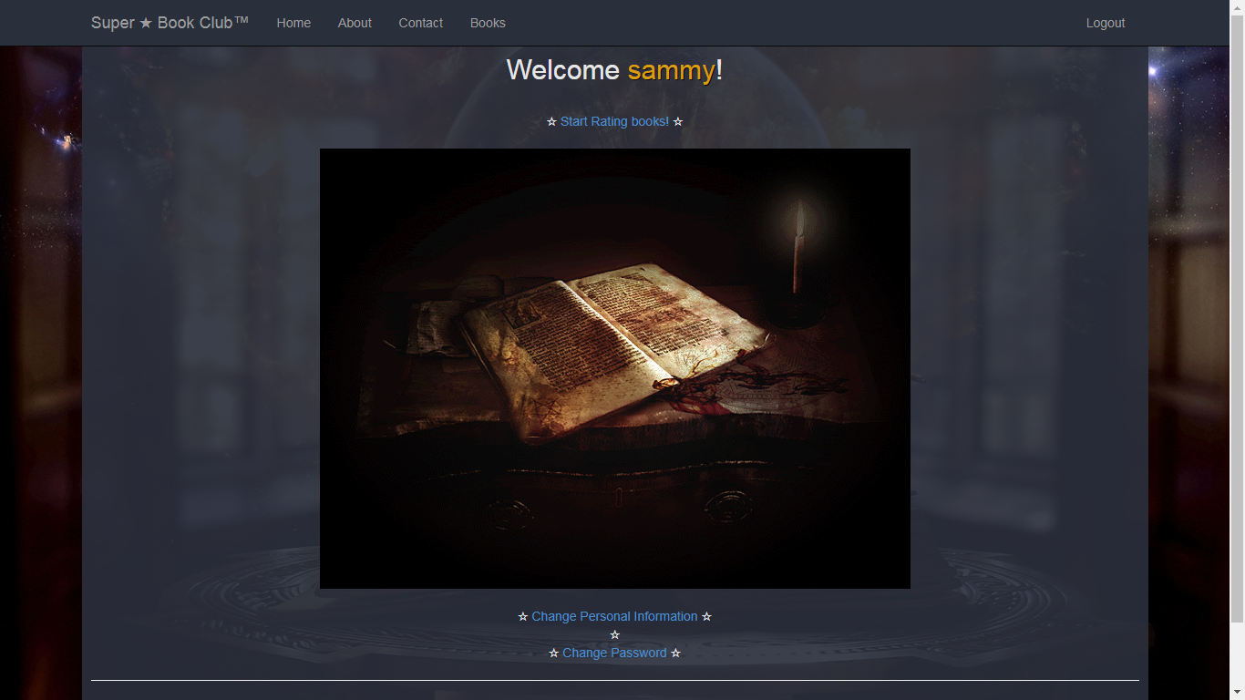

On the profile page (found by clicking on **change account details** on home page), you can change or view your personal details.

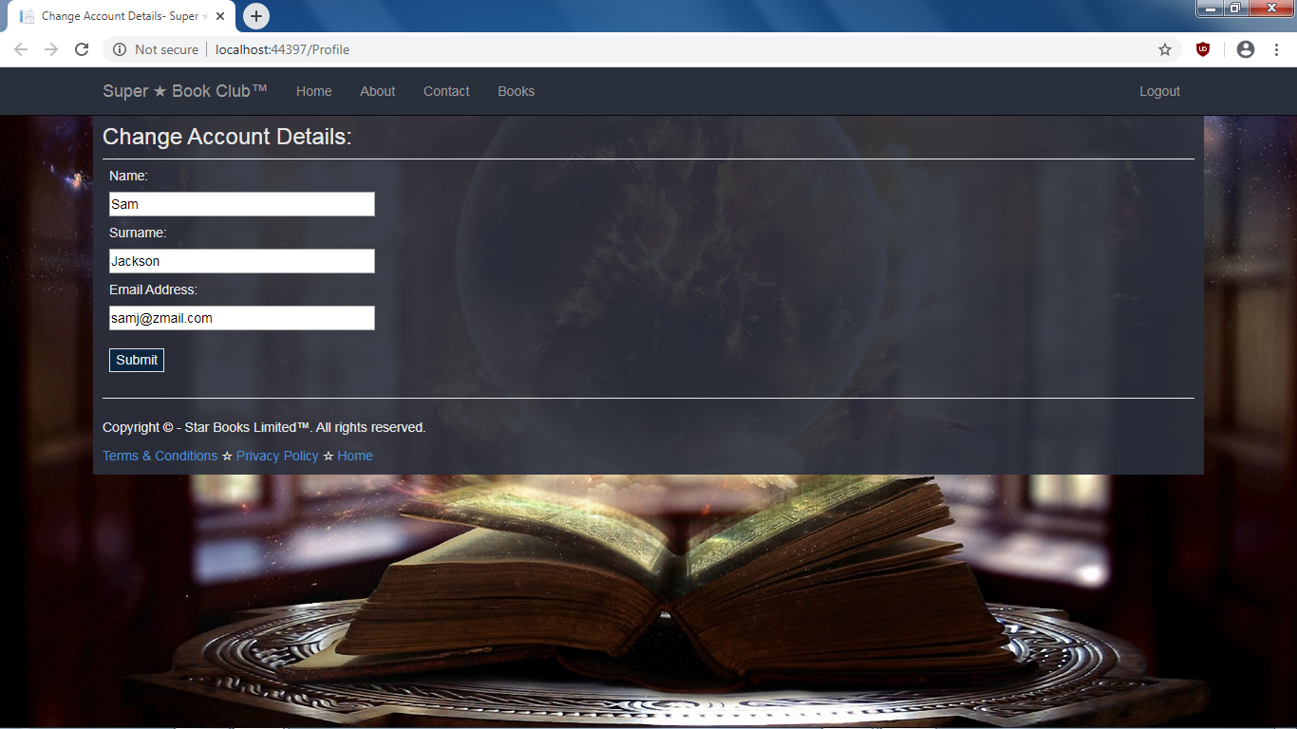

### Change Password

On the reset page (found by clicking on **change password** on home page), you can change your password. This can also be done by clicking on **Forgot your password?,** while attempting to log in.

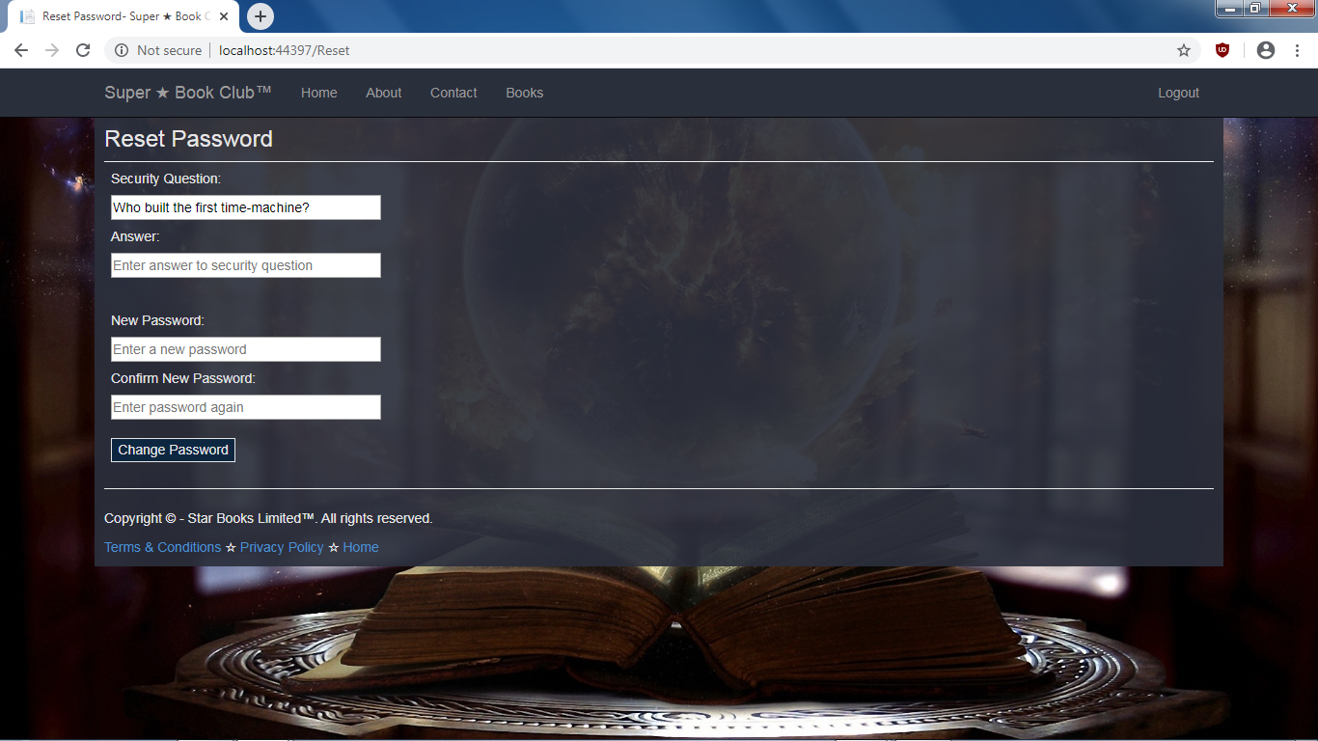

## Log File

Click on the open file icon inside the Online Book Club project in order to view the **log file**:

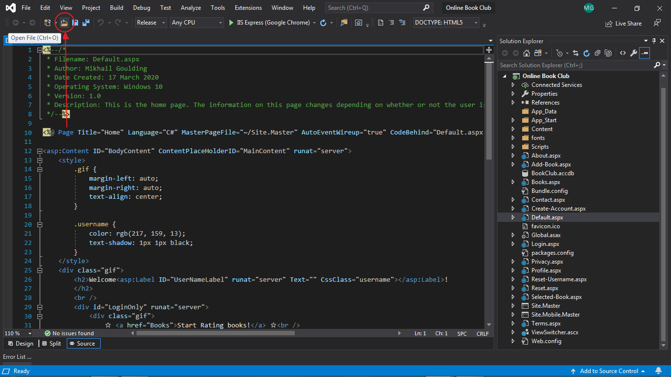

Open **ratinglog.txt** :

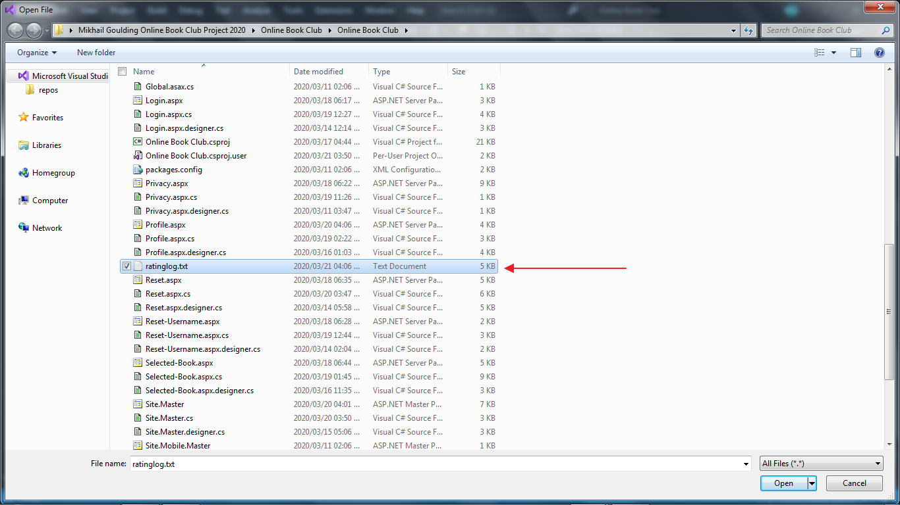

This log files logs information about user ratings. This is just a simple log file; the rating information is properly stored inside the access database.

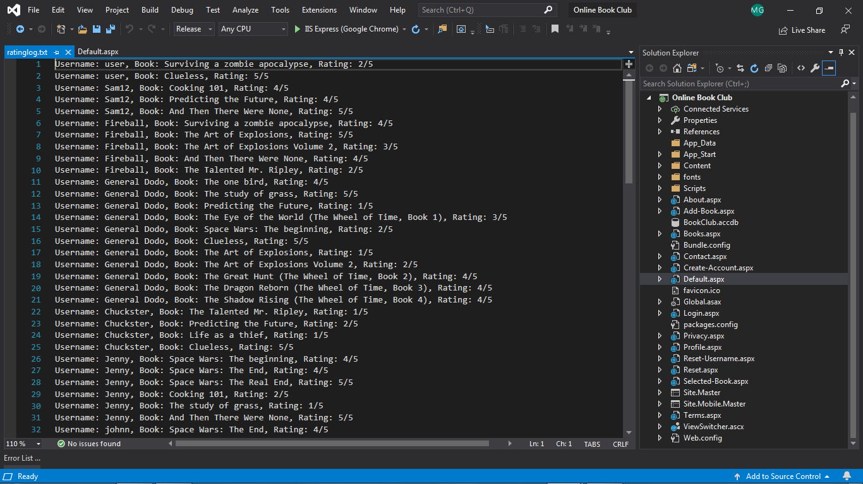

## Database

In order to view the database, open **BookClub.accdb** inside the solution explorer of the **Online Book Club** project.

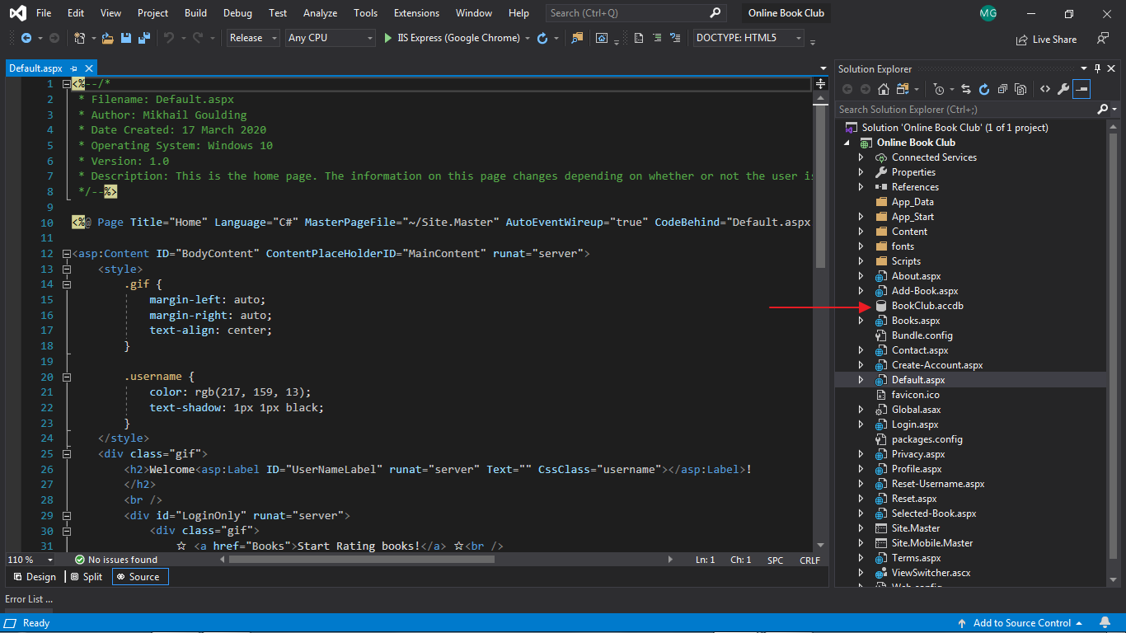

The database has 3 tables, as explained here. It is safe to read the information, but do **not** attempt to modify it. All information should be added through the website only. Preferably, do not have the database open while running the website, you might run into an **exception**: “The table *'table-name'* is already opened exclusively by another user.”

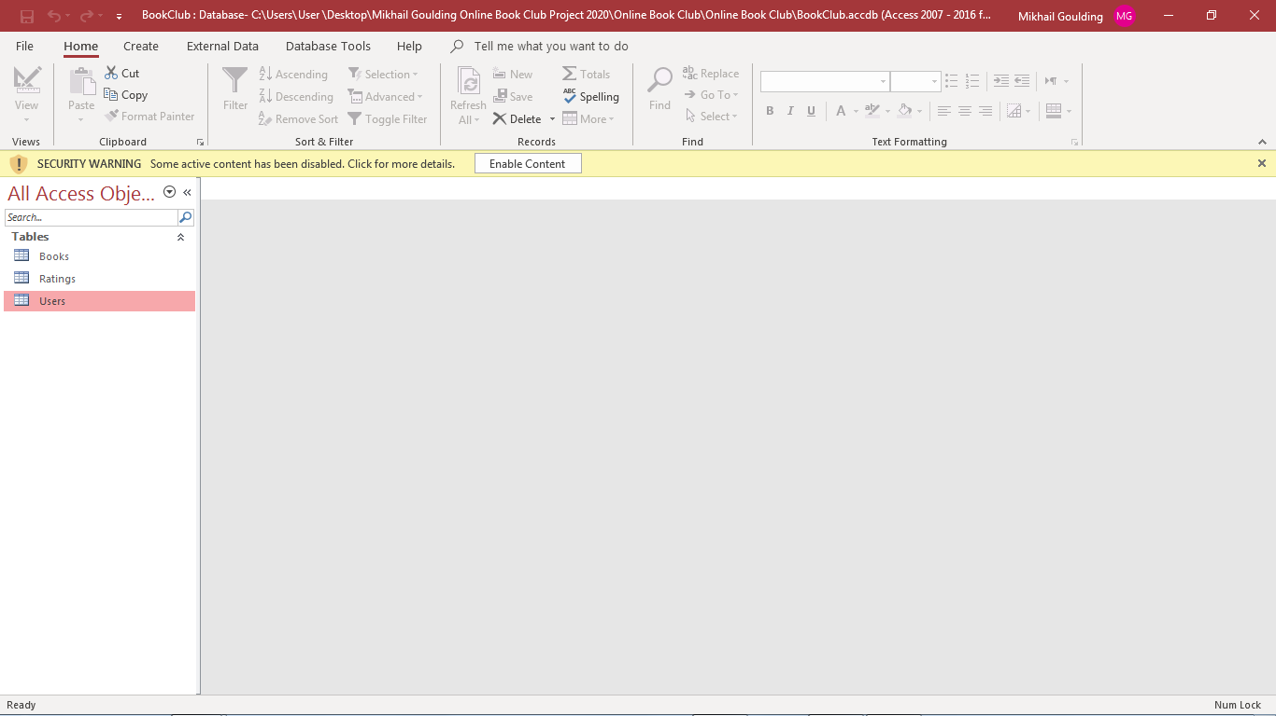

# IntelliSense warnings in the Online Book Club Project

This project has no build errors/warnings, but it does have a few IntelliSense warnings.

These warnings are false positives and should be ignored. IntelliSense does not fully support all features of HTML5, meaning it will give a warning if you use a feature of HTML5 that it does not know of. This does not in any way impact the program.

To hide these warnings, set your **Error List** in Visual Studio to **Build Only**.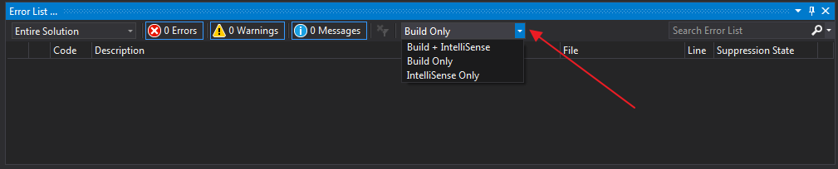

# Bibliography

* Advanced C# Programming; MLAC185-01; Compiled by: Kyle Brunette, Angelique Kolle, Lance Whyte, Cedric Maenetja, Daniel Sansom and Tatenda Tagutanazvo; Updated by: Suhayl H Asmal, Bruce McLachlan and Sheunesu Makura; Edited by: Lia Marus; Version 1.2.1; © October 2018 CTI Education Group.
* <https://stackoverflow.com/>
* <https://images.google.com/>
* <https://www.fakenamegenerator.com/gen-random-us-us.php>
* <https://termsandconditionstemplate.com/>
* <https://www.w3schools.com/>